General Formatting Guidelines

Fundamentals of Data Science

# Text & Document Formatting

Use 12-point, Times New Roman family fonts, 2.0 line spacing, and 1 inch margins all around. Name your files as YourLastName_FirstName_HW# and save as aPDF (exa: Daniels_Jerome_HW1.pdf).

# Figure & Table Formatting

When including screenshots, make sure that they are clear (do not improperly resize them) and only show the part of the screen necessary (not your whole desktop). Do not leave a lot of empty space before and after screenshots, figures, or tables. Use caption labels (Figure 1, Table 1, etc.) and short descriptions for figures and tables. Cite the screenshots, figures, or tables consistently in the text (exa: As seen in Figure 1 below, ...).

## Example

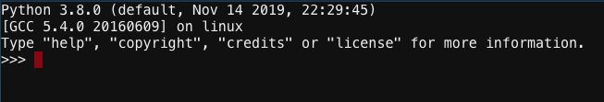

**Figure 1:** Python example screen.

# Overall Guidelines and Tips

Be sure to include descriptive text before and after screenshots, explaining what is presented. Do not assume that the reader knows what it is.

If you are unsure how to capture or modify figures or screenshots for your assignments, refer to the resources below.

**Resource:** [How to Take a Screenshot on Any Device](https://www.pcmag.com/news/how-to-take-a-screenshot-on-any-device)

**Resource:** [Detailed Guide on How to Edit a Screenshot](https://screenshot.net/edit-screenshot.html)